### 

**1. Game Title** **1**

**2. Game Concept** **1**

**3. Core Gameplay** **1**

**4. Key Features** **2**

**5. Controls** **2**

**6. Art Style** **2**

**7. Sound (Prototype)** **2**

**8. Level Design** **3**

**9. Technical Notes** **3**

**10. Scope & Goals** **3**

**11. To Fully Release** **4**

### 

### **1. Game Title**

**Project Name:** *PlaceHolder*

### **2. Game Concept**

**Elevator Pitch:**

**Genre:** Genre

**Platform:** PC (Windows) – developed in Unity

### **3. Core Gameplay**

* Player controls a character that can:  
  + Run
  + Jump
  + Shoot portals on specific surfaces
* Player must reach the exit while avoiding hazards and solving portal-based puzzles

### **4. Key Features**

* Two-color portal system (entrance/exit)
* Simple physics-based interactions (momentum through portals)
* Hazard types: spikes, lasers, moving enemies
* Minimal UI (timer, portal cooldown)

### 

### **5. Controls**

| **Action** | **Input** |
| --- | --- |
| Move | A / D or Left / Right Arrows |
| Jump | Space |
| Shoot Portal 1 | Left Click |
| Shoot Portal 2 | Right Click |

### **6. Art Style**

* **Prototype Assets:** Unity primitives (Cubes, spheres, capsules)
* **Camera:** Fixed side-view 2.5D
* Later art style ideas: stylized low-poly or sci-fi clean

### **7. Sound (Prototype)**

* Use placeholder SFX (jump, portal open, death)
* Background music: looped track (optional for prototype)

### **8. Level Design**

* 1–3 test levels
* Introduce mechanics gradually:  
  + Level 1: Basic movement & jumping
  + Level 2: Portal mechanics
  + Level 3: Puzzles with hazards

### 

### **9. Technical Notes**

* **Engine:** Unity (URP)
* **Language:** C#
* **Version Control:** Git
* Portal system uses raycasting and object teleportation logic.

### **10. Scope & Goals**

* Build in 1–2 weeks
* Focus on:  
  + Portal mechanic feel
  + Core movement physics
  + Basic enemy/hazard interaction

### **11. To Fully Release**

* Money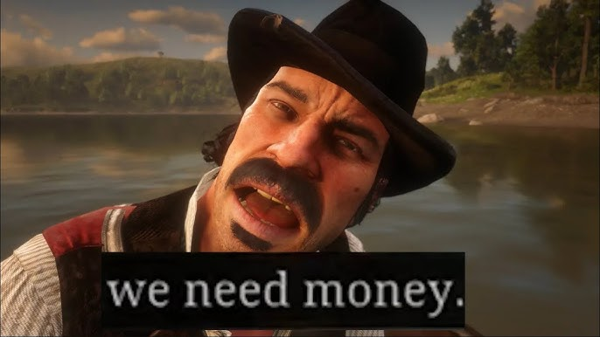
* Time

**MDA Framework**

Mechanics

The game has rotation on Q&E, Holding pieces by holding left click, releasing pieces by

releasing left click, shaky controls for added difficulty, ghost pieces where pieces are

supposed to go, with money you buy better contracts (Not Yet developed)

Dynamics

All of our mechanics work together to make a dynamic system. Rotating effects pieces,

shakiness effects rotation, bad overlap and out of build area effects rating, bad rating affects

money and ratings

Aesthetics

There are minimal Aesthetics but, the art style, audio and visual clues give a good sensation

**The MVP**

List of mechanics to fully release

* car example
  + Engine
  + Wheels
  + Clutch
  + Frame
  + Lights
  + Electricals
  + Battery